УДК 004.75
OLENA OLHOVSKA
Сandidate of physical and mathematical sciences,
Head of the Department of Computer Sciences and Information Technologies, Poltava University of Economics and Trade
ORCID: 0000-0001-5366-5995
OKSANA CHERNENKO
Сandidate of physical and mathematical sciences,
Associate Professor of the Department of Computer Sciences and Information Technologies, Poltava University of Economics and Trade
ORCID: 0000-0002-9084-0999
IRINA ANANENKO
bachelor's degree in «Computer Science»,
Poltava University of Economics and Trade
ORCID: 0009-0003-3466-9343
TATYANA PARFONOVA
Сandidate of physical and mathematical sciences,
Associate Professor of the Department of Computer Sciences and Information Technologies, Poltava University of Economics and Trade
ORCID: 0000-0001-9343-2061
NINA RUDENKO
senior lecturer of the Business Foreign Language Department,
Poltava University of Economics and Trade,
ORCID: 0000-0002-3603-8786

DEVELOPMENT OF A TRAINING SIMULATOR FOR SYSTEM ANALYSIS IN THE FORM OF A CHAT-BOT

Keywords: distance learning, simulator-bot, higher education institution.

О.В. ОЛЬХОВСЬКА
к. ф.-м. н., завідувач кафедри комп'ютерних наук та інформ. технологій,
Полтавський університет економіки і торгівлі,
ORCID: 0000-0001-5366-5995
О.О. ЧЕРНЕНКО
к. ф.-м. н., доцент кафедри комп'ютерних наук та інформ. технологій, Полтавський університет економіки і торгівлі,
ORCID: 0000-0002-9084-0999
І.В. АНАНЕНКО
здобувач освіти спеціальності «Комп’ютерні науки»,
Полтавський університет економіки і торгівлі,
ORCID: 0009-0003-3466-9343
Т.О. ПАРФЬОНОВА
к. ф.-м. н., доцент кафедри комп'ютерних наук та інформ. технологій, Полтавський університет економіки і торгівлі,
ORCID: 0000-0001-9343-2061
Н.С. РУДЕНКО
Старший викладач кафедри ділової іноземної мови,
Полтавський університет економіки і торгівлі,
ORCID: 0000-0002-3603-8786

DEVELOPMENT OF A TRAINING SIMULATOR FOR SYSTEM ANALYSIS IN THE FORM OF A CHAT-BOT
The strategic goal of educational institutions is the development of an electronic educational resource for learning, where all participants in the educational process will have equal access to mastering and practical testing of the studied materials. One of the effective methods for improving the assimilation of theoretical material and practical skills is the use of exercise programs during the educational process. The article deals with the development of an educational simulator for the distance learning course "System Analysis and Theory of Decision-Making". Methodology. Theoretical materials of the distance course, the PyCharm integrated software environment, and the Python programming language have been used. Results. In the work, a simulator program for the distance learning course "System Analysis and Decision Making Theory" has been implemented. Design and development is carried out in the PyCharm integrated environment in the Python programming language. The simulator program includes a theoretical reference, a condition of the problem, which is a task, and a number of sequential questions to solve it. Scientific novelty. The developed software product performs educational and monitoring functions. The simulator is implemented in the form of a chat bot in Telegram. The study proves that this application format is the most common among education seekers and does not require additional instructions. The methodology for developing program elements also demonstrates the step-by-step process to creating a simulator. Practical significance. The developed software product is implemented in the corresponding course of the distance learning system on the Moodle platform of the Poltava University of Economics and Trade and is recommended for use by applicants in the specialty "Computer Science" in the educational process when studying the discipline "System Analysis and Decision Making Theory"
Innovative teaching methods help applicants to fill knowledge gaps on their own without the use of additional classroom time or the help of a teacher.
Key words: distance learning, simulator-bot, higher educational institution.

Formulation of the problem. Currently, there has been a fundamental change in the methods of dissemination and use of information, which has led to the development of educational technologies and contributed to the active implementation of distance education - one of the directions of reforming the education system of Ukraine [1].
Every modern teacher faces the problem of creating their own electronic resources that organically fit into the classical system, improve and rationalize it, create new opportunities for the organization of parallel learning and knowledge management, and also provide real opportunities for individual educational practices.
Creating a simulator for mastering educational material or solving problems allows to provide effective and interactive learning, a personalized approach, motivation, progress tracking and accessibility for users. It creates a favorable environment for effective assimilation of knowledge and development of skills [2].
Analysis of recent research and publications. An important task in teaching mathematical disciplines is a visual demonstration of problem solving. To solve this problem, it is possible to develop and implement simulator programs in a distance course. The implementation of such simulators is an actual direction of development and research, in particular for mathematical disciplines.
Analyzing the existing software [3-7] (simulators, manuals, etc.), one can single out both the positives of each of them and their shortcomings. It is very important to closely monitor what is happening in the world of web development: the relevance of existing frameworks, the choice of the best among them, development and design trends. Relevant today are the initial simulators implemented in the form of chat bots.
It is very important to carefully monitor what is happening in the world of web development: the relevance of existing frameworks, the choice of the best among them, development and design trends. Educational simulators implemented in the form of chat bots are relevant today. (Актуальним на сьогодні є начальні тренажери реалізовані у вигляді чат-ботів. )
The purpose of the work is to develop simulator software in the form of a chat-bot on the topic "Expert assessment of the advantages in the problem of choosing a university" for the distance learning course "System Analysis and Decision Making Theory".

Presenting main material. The following statement of the problem is proposed: A Ukrainian family solves the problem of choosing a higher educational institution for their child entering. The family formulates requirements in the form of criteria characterizing certain qualities of universities.
Criterion 1: the presence of a large number of licensed universities in this specialty;
Criterion 2: distance from the place of residence;
Criterion 3: prestige of universities;
Criterion 4: the desire of friends to enter this university;
Criterion 5: convenience of transportation with the city where the university is located;
Criterion 6: the cost of contract training for the desired specialty;
Criterion 7: availability of a sufficient number of places in the dormitory;
Criterion 8: availability of budget places in desired specialties.
Criterion 6: the price of contract training for the desired specialty;
Criterion 7: availability of a sufficient number of places in the dormitory;
Criterion 8: availability of budget places in desired specialties.
The main goal set by the family to solve the problem is formulated as follows: "choose a university that would best meet all criteria at the same time."
Three universities (A, B, C) with such characteristics were considered as alternative ones.
University A has the largest licensed volume, significantly more than B and almost completely surpasses level C. In terms of distance from the place of residence, A significantly exceeds B, and slightly worse than C. The prestige of A among universities almost absolutely exceeds B and more than strongly exceeds C.
Regarding the preference of friends to enter the chosen university, A almost completely outperforms B and more than strongly outperforms C.
The location of universities, in terms of the convenience of transport links with the city, is very much dominated by university B. The cost of contract training in the chosen specialty at university A is twice as high as at B and C. The number of places in the hostel is sufficient. In the specialty that is given preference, university A has the smallest number of state-funded places.
University B. The licensed volume is slightly smaller than that of A, but it significantly exceeds C. It is in the worst conditions in terms of distance from the place of residence. The prestige of the university is the lowest. The desire among the friends to enter this university is the lowest. In terms of the convenience of transport connections with the city where the university is located, it is also the lowest. The cost of contract training for the desired specialty is the same as in C, and half as less as in A. The number of places in the dormitory is sufficient. In terms of the number of budget places for the desired specialties, it is very much superior to university A and not so much to B.
University C. It has the smallest licensed volume. In terms of distance from the place of residence, C has a slight advantage over B. In terms of prestige, the C university exceeds B. At the request of friends to enter the chosen university, C significantly exceeds B. In terms of convenience of transport communication with the city, the location of the university is significantly better than that of A and almost absolutely surpasses B. The cost of contract training for the desired specialty is the same as in B and half as much as in A. The number of places in the hostel is sufficient. In terms of the number of budget places for the desired specialties, the university is significantly ahead of others.
The final project of this work is the implementation of a simulator on the topic "Expert assessment of advantages in the problem of choosing a university." The main goal of developing the simulator is to help students master this topic and help them carry out calculations in an accessible and most popular format.
Step 1. The panel displays a message containing the following text: Hello, I'm a simulator bot, I will help you understand the topic "Expert assessment of advantages in the problem of choosing a university." When you're ready, click 'Get Started' and I'll provide you with the theoretical material.
The user clicks the Start button.
Step 2. The user is presented with a file called Theory.docx, which contains the theoretical information contained in the distance course. The user is introduced to the topic. Under the theoretical file is displayed: When the review is completed, click the "Continue" button.
The student clicks Continue and proceeds to step 3.
Step 3. The message sends the Problem Statement.docx file, which highlights the condition of the problem on which the student will work further. This file contains an inscription: Read the condition of the problem and click the "Continue" button, it is recommended to use Microsoft Excel for calculations. After reviewing the materials in this file, the student presses the "Continue" button and proceeds to step 4.
Step 4. The following picture is displayed on the screen:
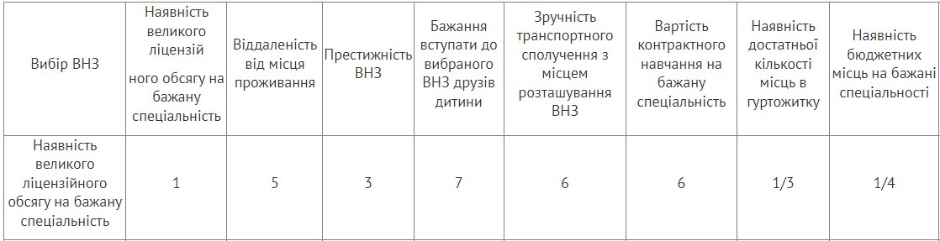
And the inscription is displayed: Calculate the components of the main eigenvector of the matrix Vi for the given series and choose the correct answer.
Suggested answers:
• 1,578;
• 0,364;
• 2,649;
• 2,053.
According to the calculations made by the user, he chooses the correct option. If this option is not the answer 2.053, we go to step 5.
Step 5. The screen displays the following image containing the calculation formula and the inscription: You have made a mistake, this formula will help you
$V_{i}≈\sqrt[n]{Д_{j=1}^{n}a_{ij}},i=1,2,…,n,$де $Д_{j=1}^{n}a_{ij}$ means the product of n factors
$a_{1},…,a_{n}.$
The suggested answer options do not change until the student chooses the correct answer.
When the student clicks on the correct answer, the program moves to the next step.
Step 6. The bot sends an image with the following message:
And below it displays the message: Calculate the components of the main eigenvector of the matrix Vi for the given series and choose the correct answer
Suggested answer options:
• 0,736;
• 0,841;
• 1,651;
• 0,956.
According to the calculations made by the user, he chooses the correct option. If this answer is not 0.736, then go to step 5.
In steps 7 - 12 of the algorithm it is proposed to calculate the components of the main eigenvector of the matrix Vi for this series. At step 13, the bot outputs the Vi vector. Next, steps 14-22 train how to calculate the components of the Pi priority vector. The next steps include the calculation of the following quantities: the maximum eigenvalue (value) of the matrix λmax; consistency index (CI); consistency ratio (CR).
Step 29. A message is displayed on the screen containing a Microsoft Excel file called Task.xlsx. This file contains the progress of solving problems. The following text is also displayed: Good job!
Open the Microsoft Excel file to check yourself. Be careful! The results of some calculations in this file differ from those presented in the distance course.
The final step. The "Start" key is displayed to the user. By clicking on it, the user ends work with the program or, if desired, can go through these tasks again.
This algorithm was implemented in the Python programming language in the PyCharm development environment.
In order to start working with the simulator, you need to write /start in the line for entering messages. Immediately after that, a message will appear, from which the user's work with the simulator will begin (Fig. 1).
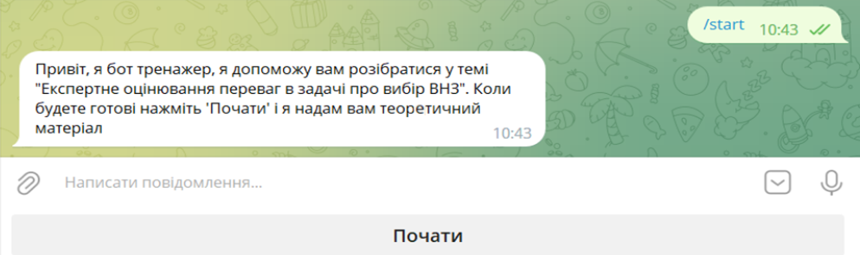
Figure 1 - Getting started with the simulator
After clicking on the "Start" button, the simulator will show the following message, which will contain the theory for the topic "Expert assessment of advantages in the problem of choosing a university." (Fig. 2).
The theoretical material and the condition of the problem will be presented to the student in .docx format, for easy mastering.
When solving problems, the condition will be presented in the form of text and / or images (Fig. 2), after reading the condition, the student must choose the correct answer, according to his calculations.
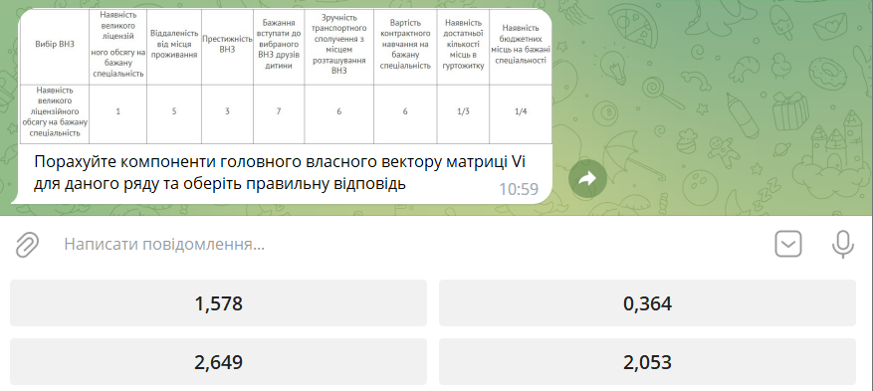
Figure 2 – Highlighting the condition of the tasks and the suggested answers

If the student chooses the wrong answer, the simulator highlights a formula that should help the student in calculations (Fig. 3).
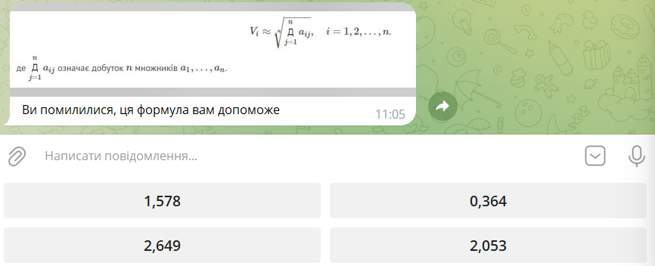
Figure 3 – Highlighting the formula to help the student
When the student answers all the questions correctly, the program sends him a .xlsx file (Fig. 4), where he can check the correctness of his thoughts during the calculations.
Figure 4 - Sending a file with the extension .xlsx

The last stage of working with this simulator is to press the "Start" button (Fig. 5).
Figure 5 – Finishing work with the simulator
After clicking on this button, the student can complete the work or start it from the beginning.
Conclusions. Thus, a training chat bot in a telegram was implemented to study one of the topics of the educational component "System Analysis and Decision Making Theory".
Non-standard and interactive methods used in conducting classes motivate applicants for education to better study disciplines and self-education, which ultimately is the main task of a modern teacher.
In the future, the created simulator program will be updated according to the curriculum of the discipline in accordance with the new State Standards and will be used as a component of the educational information environment, which makes it possible not only to approach the problem of effective integration of independent work into the educational process, but also allows without additional costs of classroom time to fill gaps in the knowledge of applicants for education.

Список використаної літератури
- Волкова, Н.П. Інтерактивні технології навчання у вищій школі: навчально-методичний посібник. Дніпро: Університет імені Альфреда Нобеля, 2018. 360 с.
- Доценко, Н. Застосування навчальних комп’ютерних інтерактивних тренажерів здобувачами вищої освіти інженерних спеціальностей в умовах інформаційно-освітнього середовища. Педагогічні науки: теорія, історія, інноваційні технології, 2018. № 2(76). С. 118–128. URL: https://doi.org/10.24139/2312-5993/2018.02/118-128 (дата звернення: 18.05.2022).
- Virk R. The Simulation Hypothesis: An MIT Computer Scientist Shows Why AI, Quantum Physics and Eastern Mystics All Agree We Are In a Video Game. Bayview Books, 2019. 330 p.
- Introduction To Computer Simulations For Integrated Stem College Education. WSPC, 2019. 234 p.
- Vlachopoulos D., Makri A. The effect of games and simulations on higher education: a systematic literature review. Intertional Journal of Education Technology in Higher Education, 2017, Vol.14 (22). URL: https://d-nb.info/1141475928/34 (Last accessed: 27.11.2020).
- Черненко, О.О., Чілікіна, Т.В., Ольховська, О.В. Розробка та використання навчальних тренажерів при підготовці фахівців напряму «Комп`ютерні науки». International scientific and practical conference ``Mathematics, physics, mechanics, astronomy, computer science and cybernetics: issues of productive interaction``: conference proceedings, Yuly 9-10. 2021. Wloclawek, Republic of Poland: ``Baltija Publishing``, 2021. C. 55-59.
- О. В. Ольховська, Д. М. Ольховський, О. О. Черненко, О. Г. Оріхівська, О. Ю. Собіборець. Технологія програмної реалізації тренажеру з теми «Системи числення, арифметичні операції в різних системах числення» дисципліни «Архітектура обчислювальних систем». ВІСНИК ХНТУ, № 3(82), 2022, С.65-74.

References
- Volkova, N.P. (2018) Interaktyvni tekhnolohii navchannia u vyshchii shkoli: navchalno-metodychnyi posibnyk [Interactive learning technologies in higher education: educational and methodological guide]. Dnipro: Universytet imeni Alfreda Nobelia. 360 p. [in Ukrainian]
- Dotsenko N. (2018) Zastosuvannia navchalnykh kompiuternykh interaktyvnykh trenazheriv zdobuvachamy vyshchoi osvity inzhenernykh spetsialnostei v umovakh informatsiino-osvitnoho seredovyshcha [The use of educational computer interactive simulators by students of higher education in engineering specialties in the conditions of an informational and educational environment]. Pedahohichni nauky: teoriia, istoriia, innovatsiini tekhnolohii, № 2(76). pp. 118–128. [in Ukrainian]
- Virk R. (2019) The Simulation Hypothesis: An MIT Computer Scientist Shows Why AI, Quantum Physics and Eastern Mystics All Agree We Are in a Video Game. Bayview Books, 330 p.
- Introduction To Computer Simulations for Integrated Stem College Education. WSPC, 2019. 234 p.
- Vlachopoulos D., Makri A. (2017) The effect of games and simulations on higher education: a systematic literature review. Intertional Journal of Education Technology in Higher Education. Vol.14 (22). URL: https://d-nb.info/1141475928/34 (Last accessed: 27.11.2020).
- Chernenko, O.O., Chilikina, T.V., Olkhovska, O.V. (2021) Rozrobka ta vykorystannia navchalnykh trenazheriv pry pidhotovtsi fakhivtsiv napriamu «Komp`iuterni nauky» [Development and use of educational simulators in the training of specialists in the field of "Computer Sciences"]. International scientific and practical conference ``Mathematics, physics, mechanics, astronomy, computer science and cybernetics: issues of productive interaction``: conference proceedings, Yuly 9-10. 2021. Wloclawek, Republic of Poland: ``Baltija Publishing``. pp. 55-59. [in Ukrainian]
- O. V. Olkhovska, D. M. Olkhovskyi, O. O. Chernenko, O. H. Orikhivska, O. Yu. Sobiborets (2022) Tekhnolohiia prohramnoi realizatsii trenazheru z temy «Systemy chyslennia, aryfmetychni operatsii v riznykh systemakh chyslennia» dystsypliny «Arkhitektura obchysliuvalnykh system» [The technology of software implementation of the simulator on the topic "Calculation systems, arithmetic operations in various calculation systems" discipline "Computer systems architecture".]. VISNYK KhNTU [KHNTU BULLETIN], № 3(82), P.65-74. [in Ukrainian]

