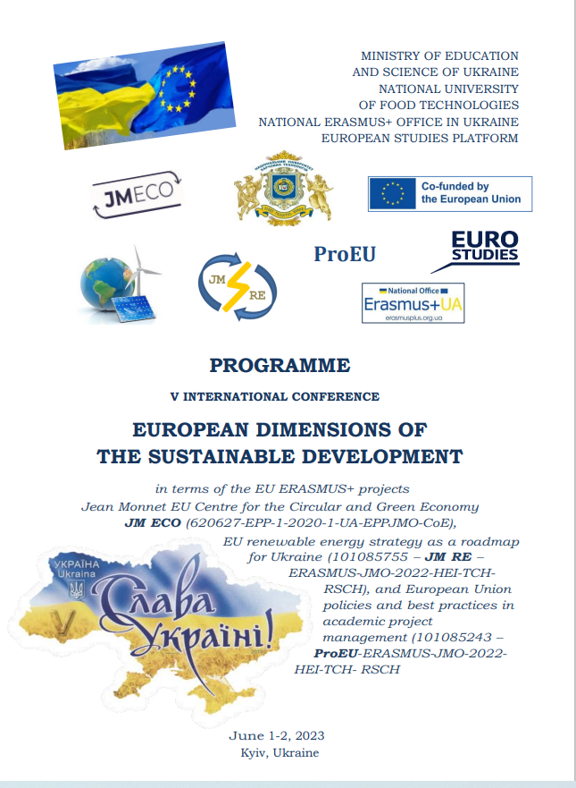

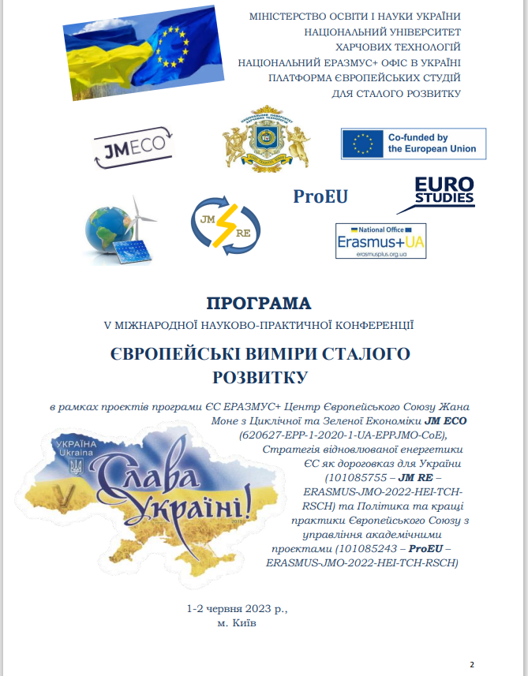
Bondar-Pidhurska Oksana. Formation of methodic for solving problems of innovative factors management of sustainable socially oriented development of the national economy. Європейські виміри сталого розвитку: матеріали V міжнародної науково-практичної конференції в рамках проєктів програми ЄС ЕРАЗМУС+ Центр Європейського Союзу Жана Моне з Циклічної та Зеленої Економіки JM ECO (620627-EPP-1-2020-1-UA-EPPJMO-CoE), Стратегія відновлюваної енергетики ЄС як дороговказ для України (101085755 – JM RE – ERASMUS-JMO-2022-HEI-TCHRSCH) та Політика та кращі практики Європейського Союзу з управління академічними проєктами (101085243 – ProEU – ERASMUS-JMO-2022-HEI-TCH-RSCH). (1-2 червня 2023 р., м. Київ). Київ:НУХТ, 2023.

FORMATION OF METHODIC FOR SOLVING PROBLEMS OF INNOVATIVE FACTORS MANAGEMENT OF SUSTAINABLE SOCIALLY ORIENTED DEVELOPMENT OF THE NATIONAL ECONOMY
Oksana Bondar-Pidhurska,
Poltava University of Economics and Trade, Poltava, Ukraine;
Email: bondarpodgurskaa@gmail.com

On the basis of complex, interdisciplinary, systemic and selective approaches, methods of analysis and synthesis, the methodic y for solving problems of managing innovative factors of sustainable socially oriented development of the economy (IFSSODE) has been developed. It is represented by a structural econometric model for assessing the state and forecasting of the IFSSODE, is based on the formed system of socio-economic indicators for the assessment of the subsystems of the IFSSODE management system, responds the criteria of stability, optimality, and efficiency of management of economic systems, allows to assess the level of satisfaction of the vital interests of the population and to make forecasts based on the Modernized Human Development Index (МHDI). The stability criterion is at least 61.8% of the middle class; the criterion of optimality is the achievement of a given level of MHDI in the minimum period of time; the efficiency criterion is the achievement of a given level of MHDI with minimally sufficient investments.
The developed methodic of assessment and forecasting of sustainable innovative socially oriented development of the national economy consists in conducting a comprehensive analysis of the economic, social, ecological subsystems of the IFSSODE management system based on the index method, factorial and correlation-regression analysis on two contours of the economic system that meet the conditions of stability (more than 61, 8% of the population whose vital interests are satisfied) and instability (less than 61.8% of the population whose vital interests are satisfied).
At the same time, in the first case, GDP per capita was chosen as the objective function, and in the second, the human development index (HDI). Sequential implementation of the four stages of the developed methodic for solving IFSSODE management problems, namely planning; organizations and analytics; the selection of alternatives according to the criterion of credibility on the first (GDP) and second (HDI (МHDI)) contours, as well as control will allow to single out the existing trends of the main managed parameter of the IFSSODE management system and draw conclusions about the effectiveness of management decision-making by state regulatory bodies [1-2].

References:
1. Bondar-Pidhurska O. V., Solovyov V. P. The strategy of sustainable innovative society-oriented development of Ukrainian economy (by the example of mineral resource industry). Scientific bulletin of National Mining University. 2017. № 4 (160). Р. 122–132.
2. Бондар-Підгурська О. В. Розробка структурної економетричної моделі управління інноваційними факторами сталого соціально орієнтованого розвитку економіки. Економіка і регіон. Науковий вісник ПолтНТУ. 2016. № 6 (61). С. 12–19.
